Lab 1 — Task 1: Install and Configure Git and Jenkins
Anant Goel Ubuntu 26.04 LTS on AWS EC2 (ap-south-1)

Objective
Install and configure Git on Ubuntu Linux, verify the installation, and set up the global Git configuration (user name and email). Jenkins is also installed and verified as a running service.

Environment
Platform : AWS EC2 (Asia Pacific - Mumbai, ap-south-1)
Instance : i-0b3a412e4be4292c1 (Devops_lab)
OS : Ubuntu 26.04 LTS (GNU/Linux 7.0.0-1006-aws x86_64)
Access : EC2 Instance Connect (browser-based SSH)

Step 1 — Install Git
The package index is refreshed and Git is installed from the Ubuntu repositories.
sudo apt update
sudo apt install -y git

Step 2 — Verify the installation
The installed version is confirmed with:
git --version
Output: git version 2.53.0

Step 3 — Set the global Git configuration
The identity used to author commits is set globally, along with the default branch name for new repositories.
git config --global user.name "Yatharth Chopra"
git config --global user.email "yc9891966@gmail.com"
git config --global init.defaultBranch main

Step 4 — Verify the configuration
git config --global --list
Output:
user.name=Yatharth Chopra
user.email=yc9891966@gmail.com
init.defaultbranch=main

Screenshot — Git installation and configuration
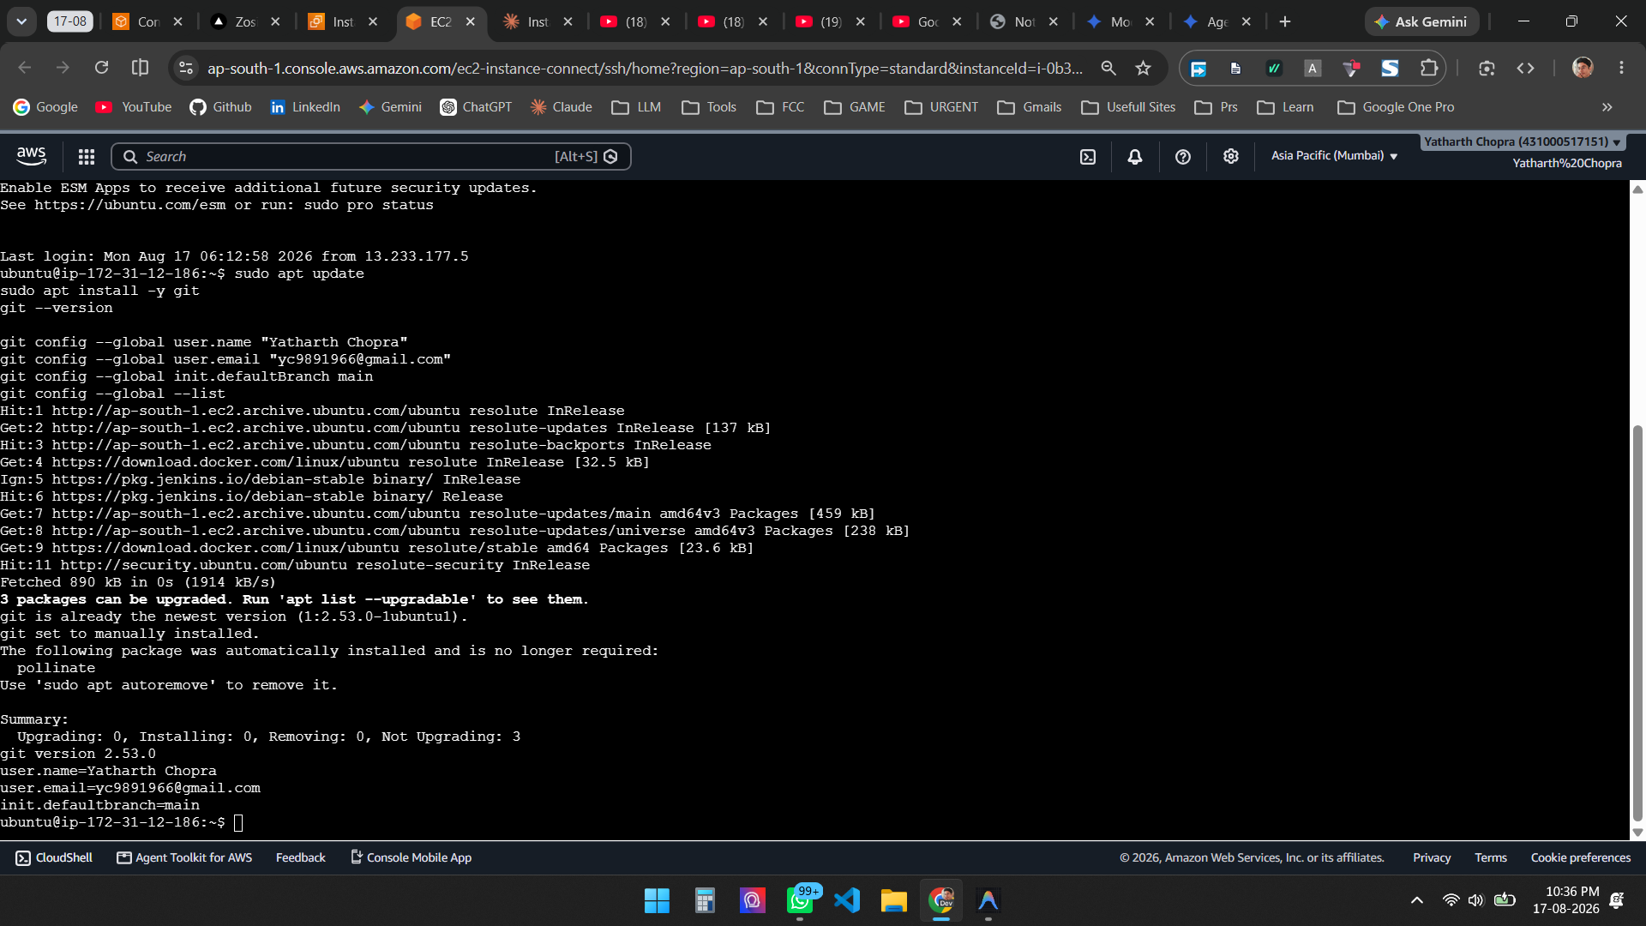
Figure 1 — Git installed (v2.53.0) and global configuration verified via git config --global --list

Jenkins Installation
Jenkins was installed from the official Jenkins LTS apt repository. Java 21 (OpenJDK) was installed first as a prerequisite.
sudo apt install -y fontconfig openjdk-21-jre

curl -fsSL https://pkg.jenkins.io/debian-stable/jenkins.io-2026.key \
| sudo tee /usr/share/keyrings/jenkins-keyring.asc > /dev/null

echo "deb [signed-by=/usr/share/keyrings/jenkins-keyring.asc]" \
"https://pkg.jenkins.io/debian-stable binary/" \
| sudo tee /etc/apt/sources.list.d/jenkins.list > /dev/null

sudo apt update
sudo apt install -y jenkins
sudo systemctl enable --now jenkins
sudo systemctl status jenkins --no-pager
Note: the Jenkins project rotated its Linux repository signing keys, so the current 2026 key is required. Using the older 2023 key produces a NO_PUBKEY 7198F4B714ABFC68 error and the jenkins package cannot be located.

Screenshot — Jenkins service running
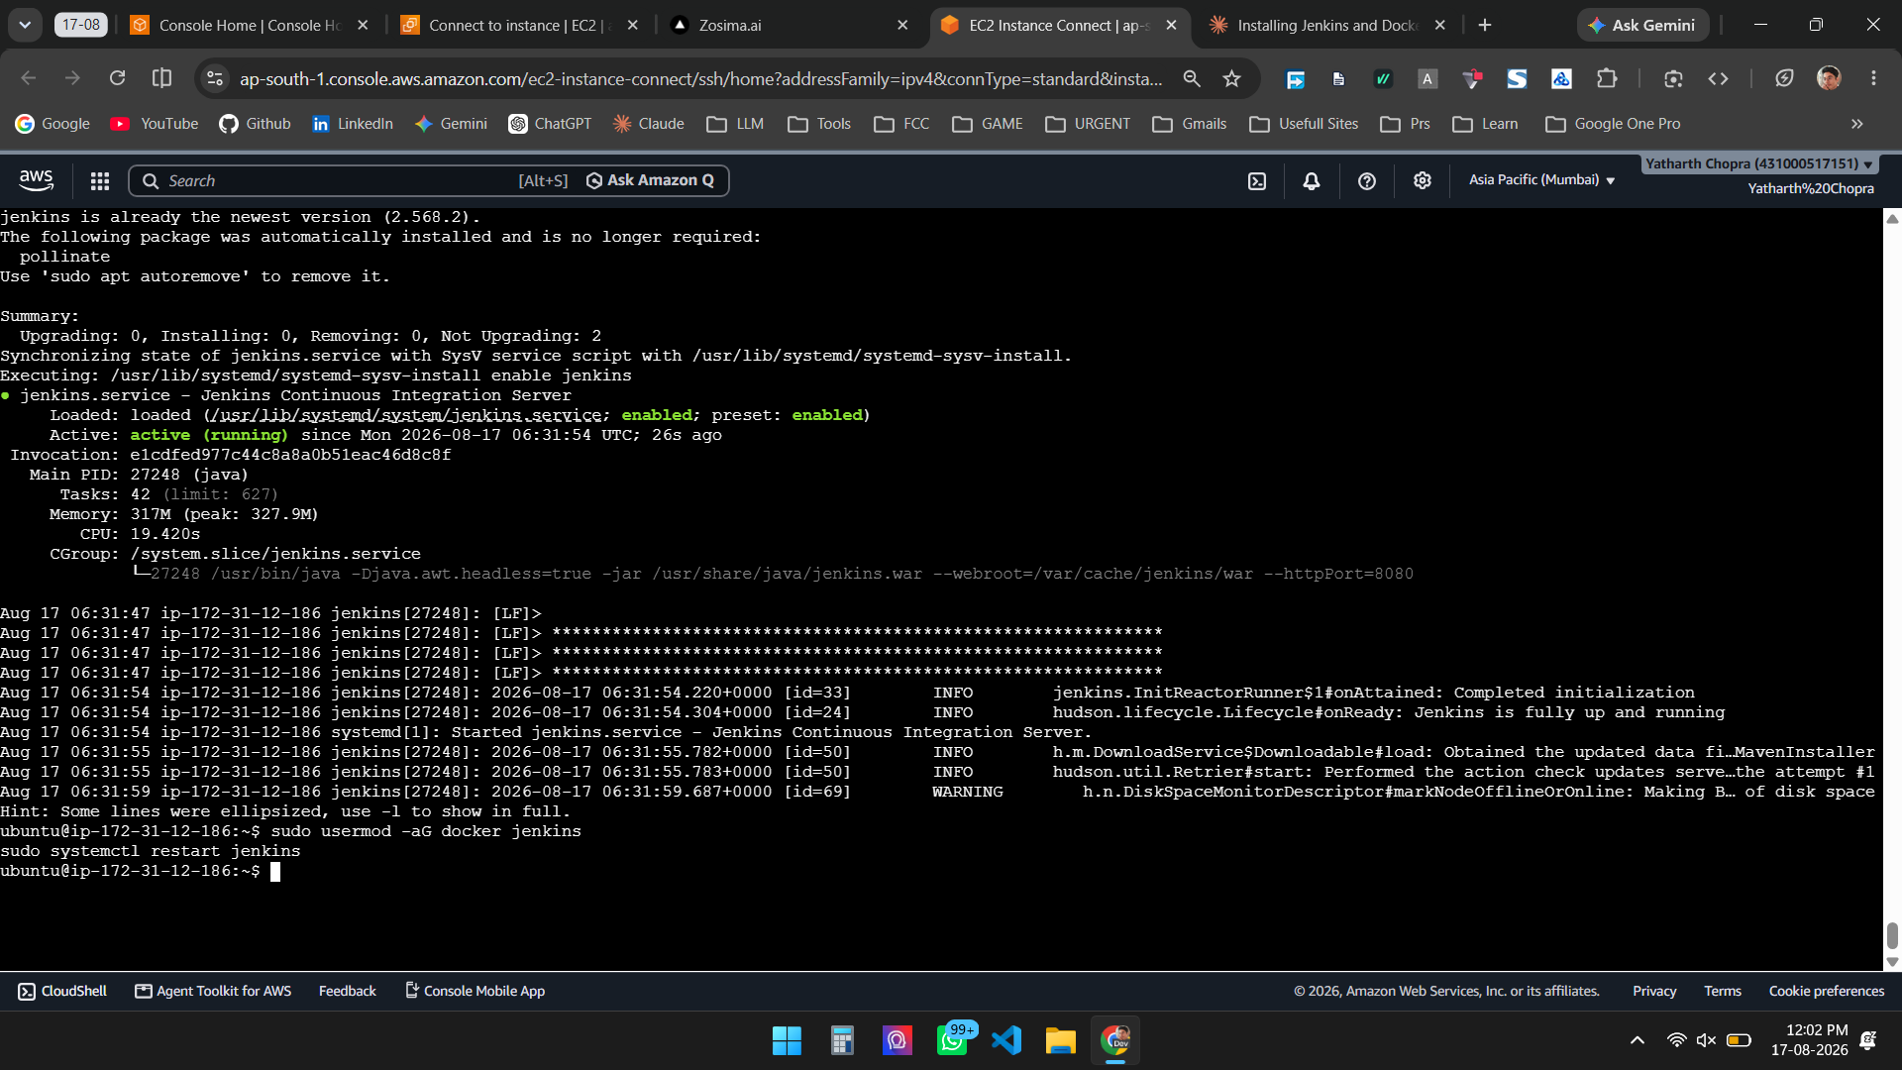
Figure 2 — jenkins.service is enabled and active (running), listening on port 8080

Screenshot — Jenkins web interface
Port 8080 was opened in the EC2 security group, and the Jenkins setup wizard was completed by installing the suggested plugins.
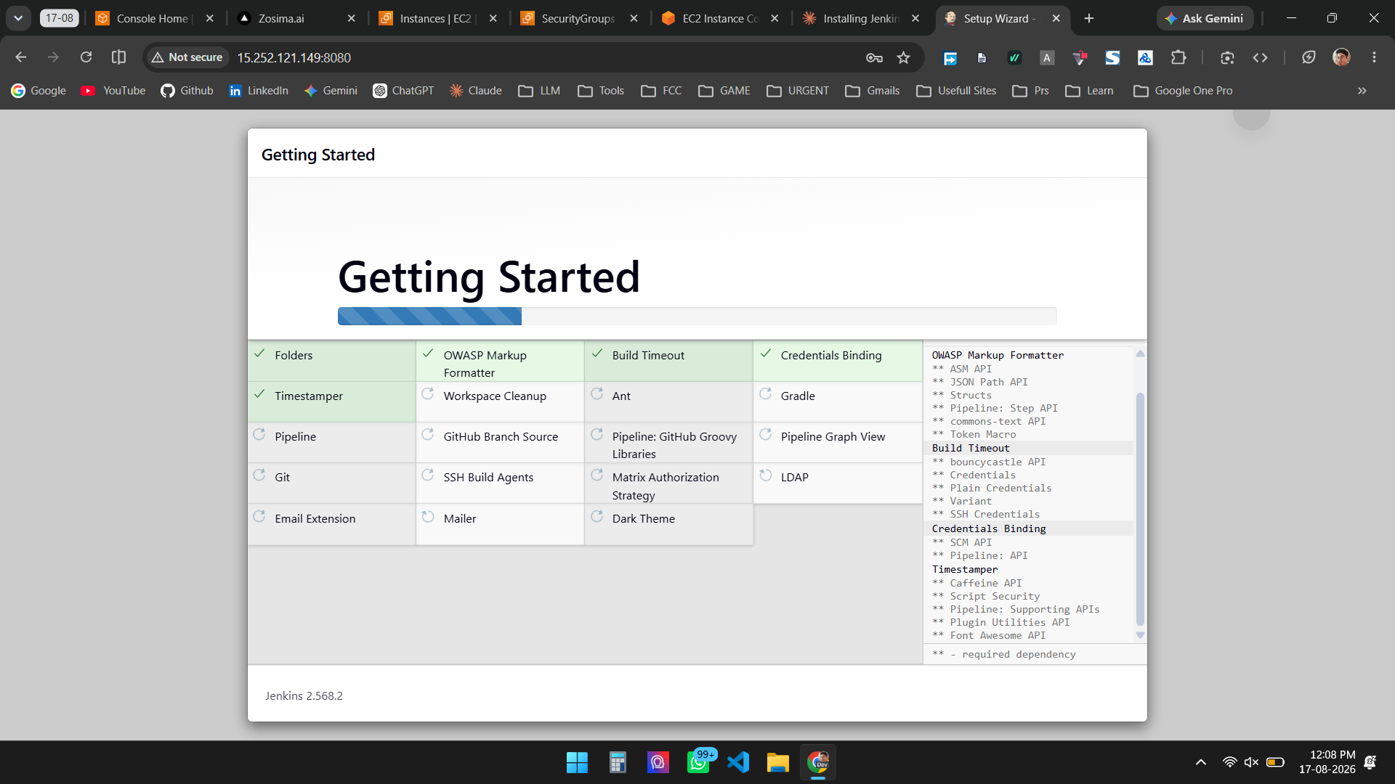
Figure 3 — Jenkins 2.568.2 setup wizard installing the suggested plugins at http://15.252.121.149:8080

Result
Git 2.53.0 is installed and configured with the global user name and email. Jenkins 2.568.2 is installed, enabled at boot, running as a systemd service, and accessible through its web interface. Task 1 is complete.

